Finger Flash - One More One Less 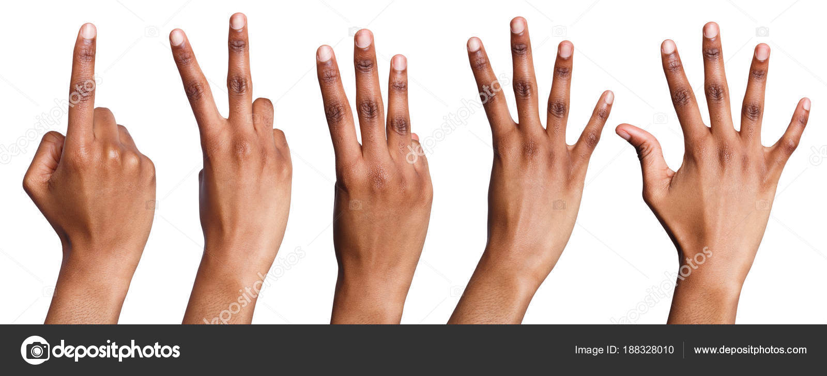

This game is designed to help students develop conceptual understanding of the relationship between numbers using their fingers. Use of fingers in math is an important early strategy for internalizing the relationship between numbers. Once mastered students can understand advanced representations and models for numbers. The game is designed to build mental math skills using physical movements and quick recall. This game is a precursor to fluency in using and manipulating the number line, addition, subtraction, \ and more foundational math skills.

**Materials:** Just your hands!

**Play**: Begin by showing the student a balled fist that represents “zero” progress showing the numbers 1-10 using your fingers. Consider how you’ll position your hand and be consistent in how you’ll show your hand to the student. ( Teacher Tip: may want to do some hand/finger stretches first!

**Level 1:** Once a student has a strong understanding of what each number “looks like” on your hand begin flashing random numbers 0-10 to them. Show your hands for about 3 seconds and drop them. The student should call out the correct number first before moving to a new number. If they are incorrect, flash the number again.

**Level 2:** Get creative in how you flash the numbers. So rather than showing the number “6” with 5 on one hand and 1 on the other, flash three fingers up on both hands.

**Level 3:** We can flash numbers above 10! Begin by teaching “20” as two flashes of 10. Be slow and deliberate at this point so the student knows you purposely showed ten twice. Continue showing 30,40, 50 and so on until 100. Students will probably track large numbers by calling out the skip count.

**Level 4:** We can flash any 2 digit number! This one is great for building understanding of place value. Begin with teaching “11” as a flash of ten fingers. Drop your hands and nod your head deliberately and then hold up 1 finger. The head nod signals a switch from tens to ones. So you are essentially building an equation “10+1=11). Continue teaching how 12-19 looks.

**Level 5:** Flash any number between 0 and 100 by combining levels 3 and 4. Be sure to always flash the groups of ten followed by the ones. For example 57 would be 5 flashes of ten, a head nod, and then a flash of 7 with any combination of fingers you want. This is great on the go game to fill time.